PAIL

ASSIGNMENT 1 – LAB 1



Name:Partha Sharma

Class: SY-06

RollNo:35

EnrollmentNo:ADT24SOCB0758

GitHub Repo: https://github.com/Partha-sh/Assembly



1. Hello World : A simple assembly program that prints “Hello, World!”.

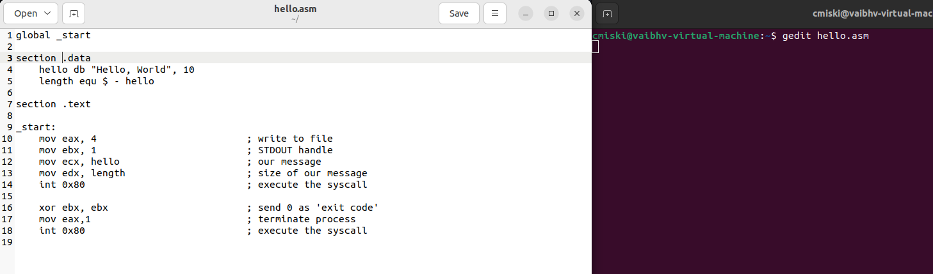

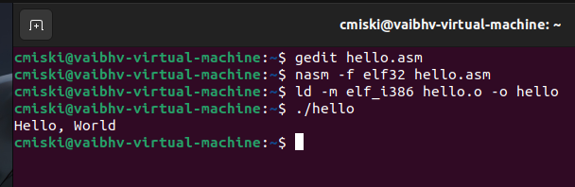

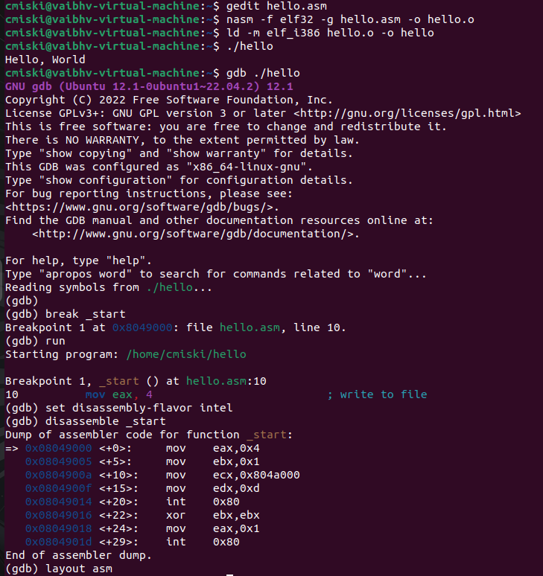

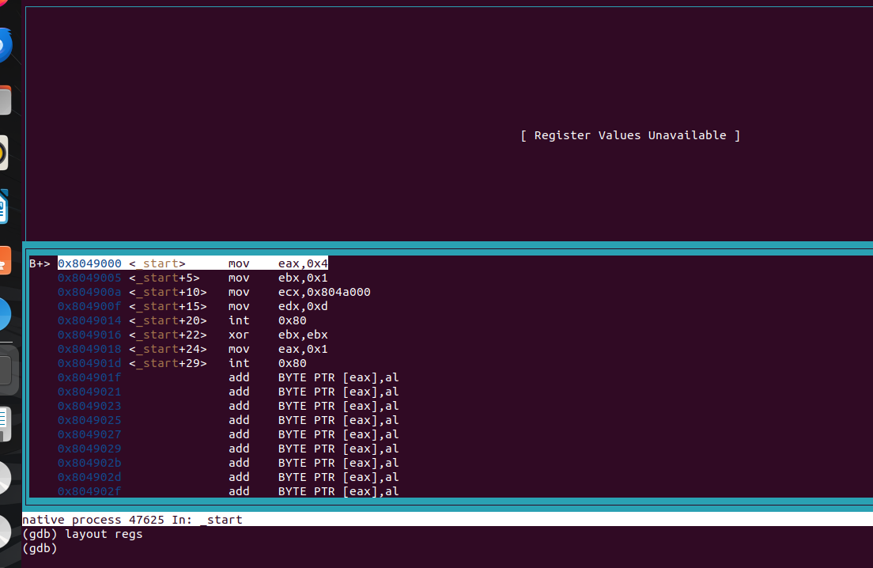

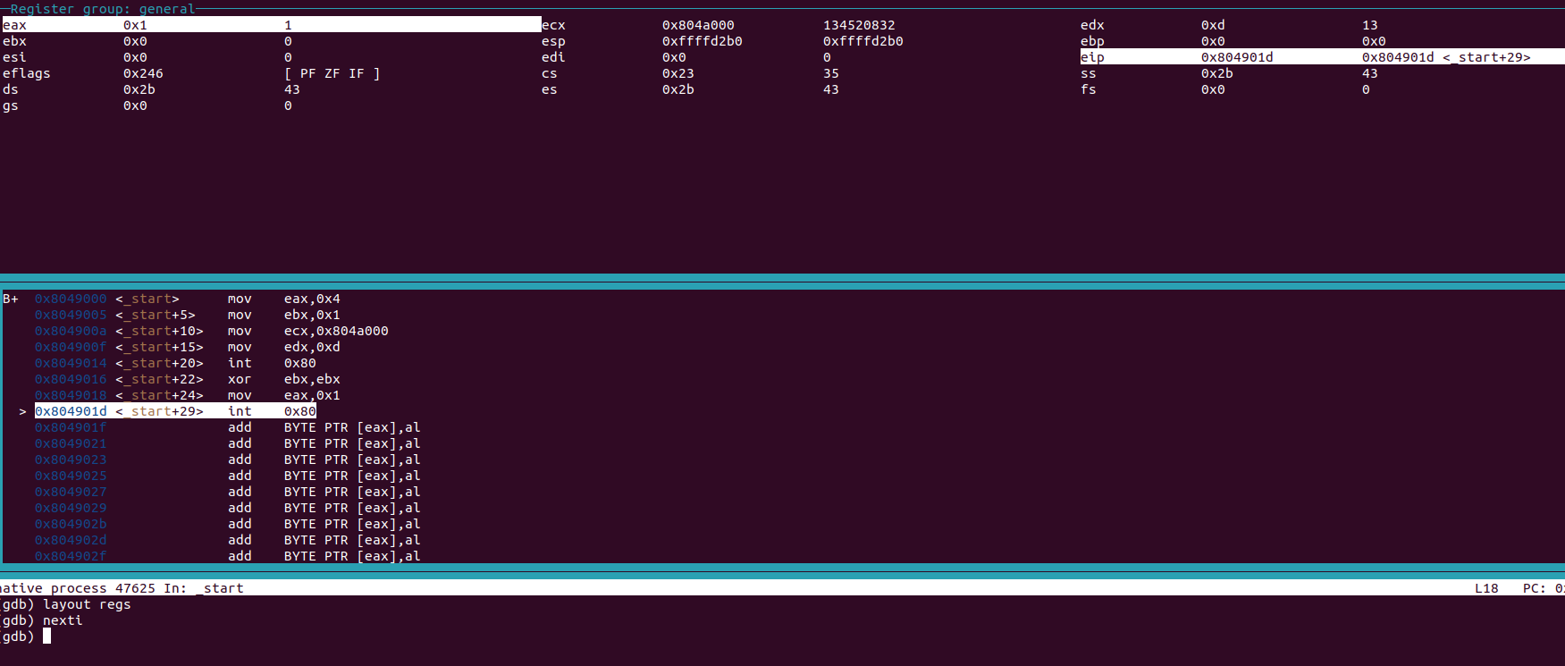

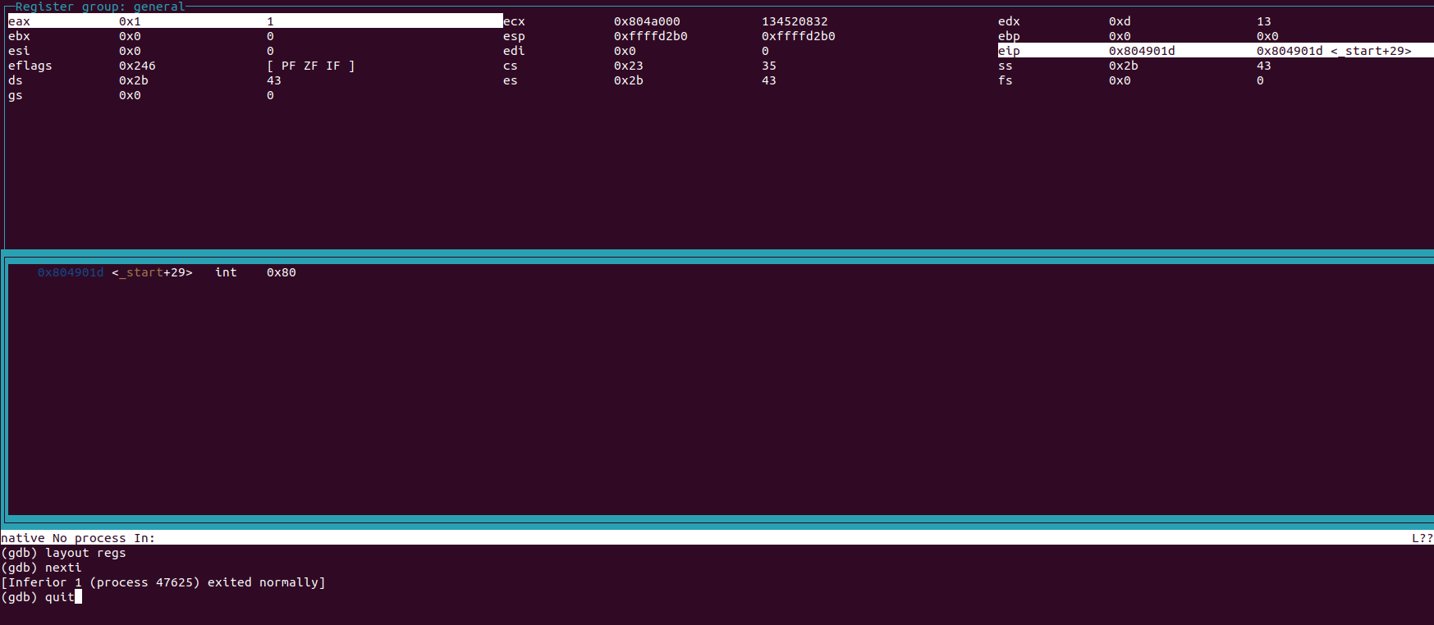



2: Print Name & Surname – Prints my name on the first line and my surname on the second line.



